

OPERATING MANUAL

TYPE 001PLC

UNIT 8 - WHITEBRIDGE INDUSTRIAL ESTATE
STONE
STAFFORDSHIRE ST15 8LQ
ENGLAND
TEL: +44 (0) 1785 815651
FAX: +44 (0) 1785 812115

MCP EQUIPMENT
UNIT 8, WHITEBRIDGE INDUSTRIAL ESTATE - STONE - STAFFORDSHIRE ST15 8LG
ENGLAND
TEL. (+44) 01785 815651 - FAX. (+44) 01785 812115
Email: equipment@mcp-group.co.uk - Web:

A DIVISION OF MINING & CHEMICAL PRODUCTS LTD.

Thank you for choosing an MCP vacuum casting machine.

The equipment, which is controlled by a PLC, combines a vacuum pump with fast exhaust rate and a highly efficient mixing unit to ensure the production of premium quality castings in a variety of moulding materials.

The vacuum chamber itself is used for de-gassing both the silicone rubber mixture from which moulds are formed, and the two-component MCP resins used for the actual castings.

Please follow carefully the instructions for installation and use that are to be found in this Operating Manual, which also covers routine checks and adjustments. A separate SERVICE MANUAL is provided to deal with specific repairs, fault-finding and replacements.

A further Manual, VACUUM CASTING TECHNIQUE, gives an overview of the system. A copy is supplied with every machine.

HEALTH AND SAFETY

All units supplied on or after 1st January, 1995, bear the CE mark. The Declaration of Conformity will be found at the end of this Manual.

ELECTRICAL SAFETY
Certain of the tasks described in this manual require access to the electrical control enclosure, and should therefore be carried out only by a suitably qualified person.

MATERIALS SAFETY DATA
Though no special hazard is likely when they are used in accordance with the suppliers’ recommendations, each of the materials used in the process is the subject of a Safety Data Sheet, supplied at the time of first purchase and giving information in conformity with both European Directive 91/155/EEC and (in the United Kingdom) the Consumer Protection Act 1987.

NOISE
The equivalent continuous A-weighted sound-pressure level during working of this machines does not exceed 70dB(A).

CONTENTS

Page

INSTALLATION
Weight and dimensions 7
Power requirements 7
Siting the machine 7
Installation sequence 8-9

PREPARATION FOR CASTING 10
Preparing the mould and flow-system
Preparing the resin
Fitting the cups and paddle

WORKING PROCEDURES 11
To make the machine ready for use
Operating modes / Control Panel Touch Screen Functions 13
Operating in manual mode 20
Using the automatic operating sequence
Stopping in emergency
Re-starting after emergency
Shutting down 12

CONTROL PANEL TOUCH SCREEN FUNCTIONS 13
Manual functions
Auto functions

ROUTINE MAINTENANCE PROCEDURES 22

DECLARATION OF CONFORMITY 23

Illustrations

Fig. 1 General front view 2
Fig. 2 General view with chamber open 3
Fig. 3 Rear view with access panel open 4
Fig. 4 Operating panel 7
Fig. 5 Adjusting the paddle and holder 8
Fig. 6 The control panel 9
Fig. 7 Arrangement of the mould and accessories 10

Standard accessories: Illustrations and Part Numbers 5-6

VACUUM CASTING MACHINE

TYPE 001PLC

Control panel

E-Stop panel
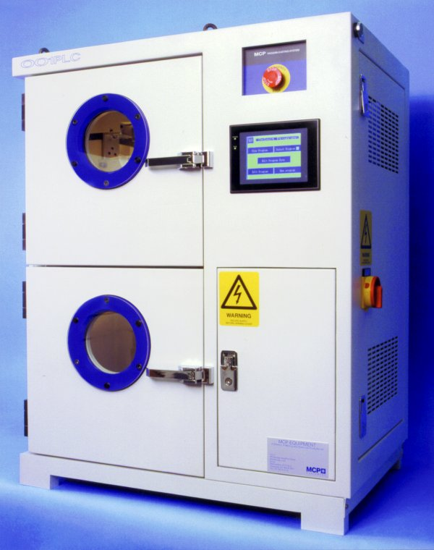

Re-set button (green)

Lockable door-catches
(side access panel)

Main isolator switch
(red/yellow)

Lockable door-catch
(pump access area)

Fig. 1 General front view

VACUUM CASTING MACHINE

TYPE 001PLC

Cup A

Stirrer motor assembly

Cup B

Funnel platform

Separate upper and lower chamber doors

Lower (mould) chamber

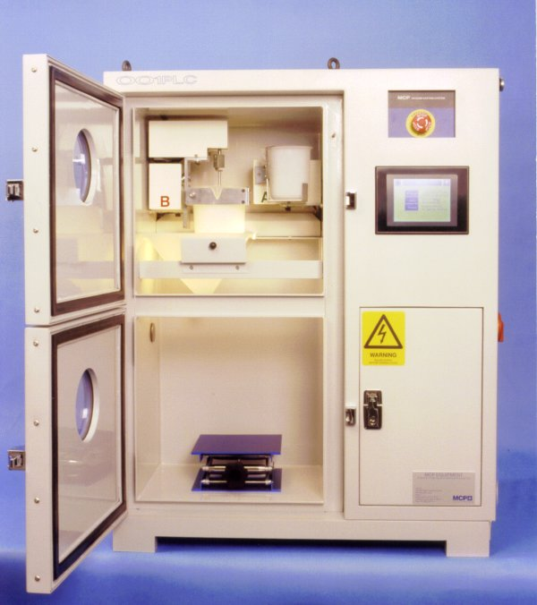

Fig. 2 General view with chamber open

VACUUM CASTING MACHINE
TYPE 001PLC

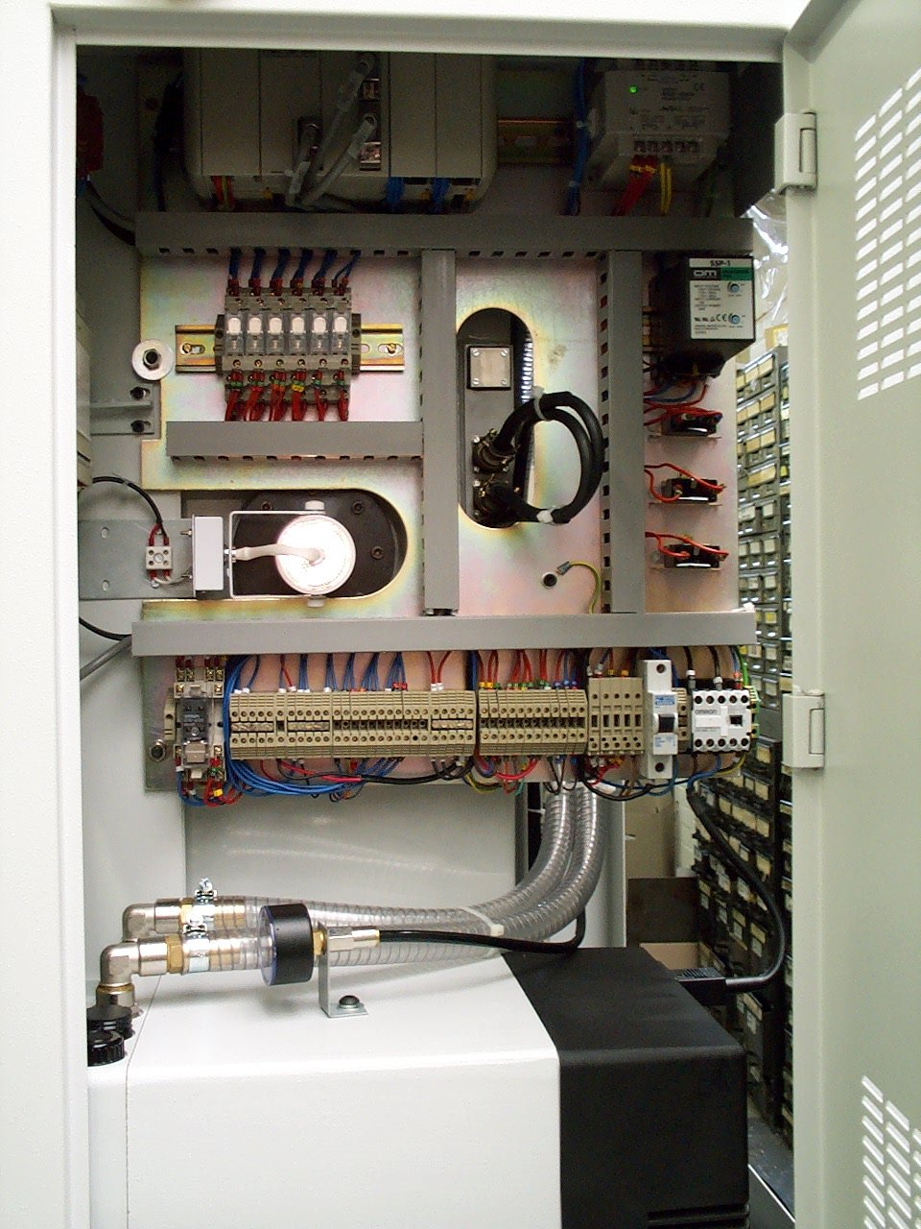

Fig. 3 Side view with access panel open

STANDARD ACCESSORIES RANGE
( NOT AVAILABLE FOR 001PLC)

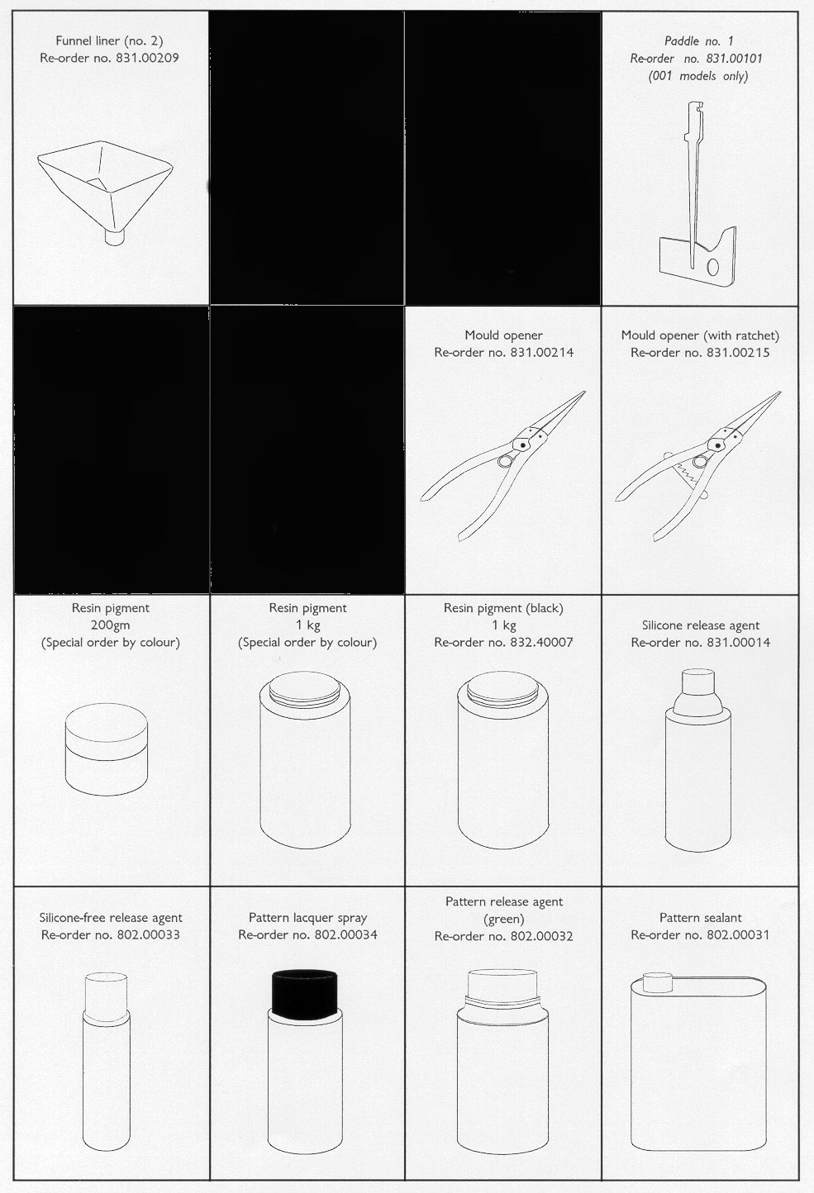

STANDARD ACCESSORIES RANGE
( NOT AVAILABLE FOR 001PLC)

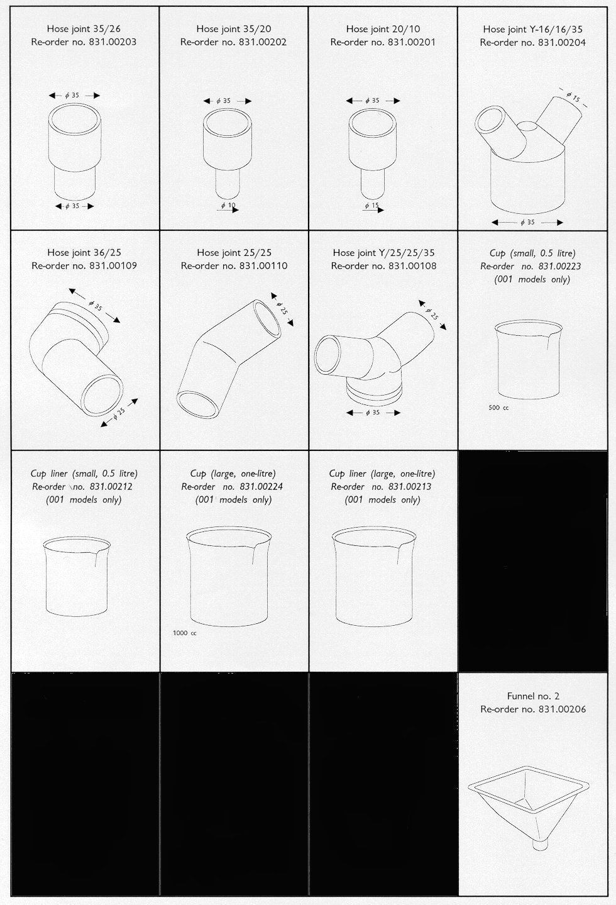

INSTALLATION

WEIGHT AND DIMENSIONS

* Weight: shipping weight, 219kg; unpacked 194kg
External dimensions (mm):1100 high x 840 wide x 550 front-to-back.

POWER REQUIREMENTS

* The unit requires a single-phase, 230 volt supply.
Normal current rating, 6.5A; maximum surge 16A.
In countries of the European Union, units are supplied with the appropriate plug, fused as necessary.

* An earthing point and a circuit-breaker must be provided.

SITING THE MACHINE

* Do not site the unit in an area subject to excessive heat or high humidity.

* Choose a well-ventilated room. If possible, provide local exhaust ventilation to an outside vent.

* Avoid areas exposed to dust or vibration.

* If required, the complete unit may be lifted by slinging from the three eye-bolts mounted on the top of the cabinet.

* Ensure that the unit stands on a level surface (adjustable feet are not provided)

INSTALLATION SEQUENCE

Before installing, please read through the instructions and ensure that you can identify each of the parts referred to.
Note that access to the main electrical panel is by the lockable side panel on the right-hand side of the cabinet.

- Open the vacuum pump access panel. Check the oil level and, if necessary, fill the vacuum pump to the level indicated by a market on the sight glass using the oil supplied.
Close the access panel

- Ensure that the main isolator is set to ‘OFF’ and
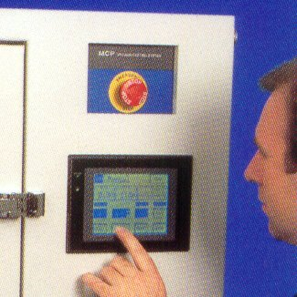
that the Emergency Stop know (fig. 4) is pushed
into the ‘OFF’ position.

- Open the side electrical access panel and ensure
that the circuit breaker switch is in the ‘up’
position (i.e. switched on). Make and check the
earth connection to the unit.
Close the access panel.

- Connect to the power supply, using the cable and
plug supplied
Fig. 4 Operating panel
- Switch on at the main isolator switch.

- Release the Emergency Stop knob by turning it anti-clockwise.

- Press the ‘Re-set’ (green) button (at the top right side corner of the machine).

INSTALLATION continued

- Check that the chamber illumnation light is now on. If it is not, turn off the machine at the isolator, open the side access panel and check the light-bulb.

- Insert and adjust the mixing paddle (fig. 5).

Note that the paddle has a slot (1) which fits over a pin within the slot in its holder and is retained by pressure from a spring-loaded steel ball. The locked grubscrew (2) that carries the ball may be adjusted (using an M6
spanner and 3mm AF Allen key): it should be possible to remove and replace the paddle by hand, without slackness when it is in position.

A cup and liner should be in position while height adjustment is made. To adjust the height, use a 2mm AF Allen key to slacken the grubscrew (3) to allow the holder to slide up or down the shaft. When correctly positioned, the paddle should rotate with a clearance
of 1-2 mm from the cup liner. Re-tighten the grubscrew.

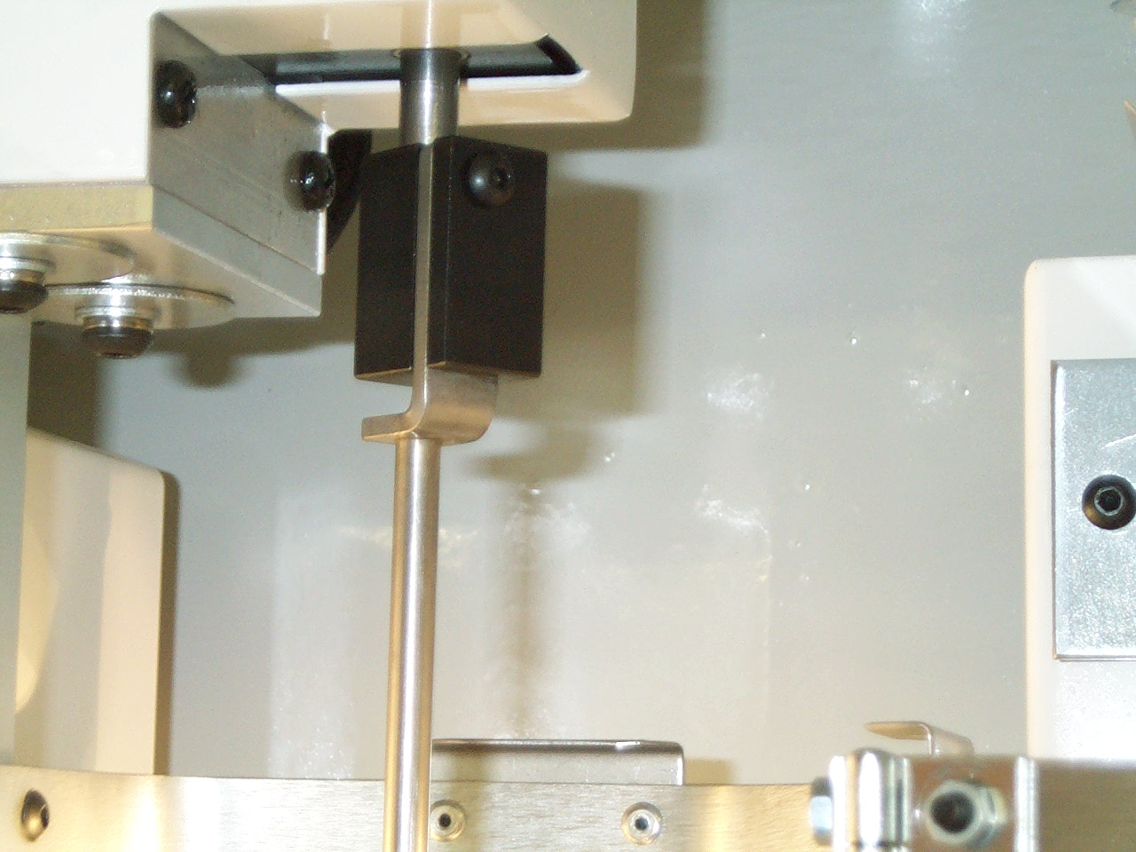

Fig. 5 Adjusting the paddle and holder

- The slow leak valve is accessible from the back panel (fig. 3). Check the adjustment of the flow-control governed by this device. The valve handle should be inclined at approximately 45º to the valve body.

WARNING
DO NOT operate the vacuum pump for longer than 30 seconds while the vacuum chamber is open. Failure to observe this precaution might result in excessive wear on the pump’s components.

PREPARATION FOR CASTING

The sequence of operations (explained in general terms in the companion Manual VACUUM CASTING TECHNIQUE) requires the resin component cups, the whisk for mixing, a funnel and hoses all to be put correctly into place above the entrance gate(s) to the mould.

PREPARING THE MOULD AND FLOW-SYSTEM
The standard accessory range includes several joints (see page 5), which may be employed in conjunction with clear plastic hose to direct the mixed resin into the mould, with the flow being spilt through Y-joints if need be
Fit the funnel (see fig. 7) into the centre of the carriage in the upper part of the chamber, locating the front edge over the guard plate on the funnel position, and place the prepared mould (on a support platform in necessary) in the lower chamber. NB – do not use any form of support which might inflate under vacuum.

Decide on the pattern and sizes of hose and any connectors that may be needed, keeping the runs as short as conveniently possible.

Prepare the hose outlets, fixing to both funnel and mould. Ensure that you obtain a good fit, but one that is not too tight. Leave no end open.

PREPARING THE RESIN

Two- or three-component resins should be prepared in accordance with the supplier’s instructions and placed in the appropriate cups.

Although casting may be carried out without them, it is recommended that cup liners be always used.

For general guidance, refer to the manual Vacuum Casting Technique: a guide for new users supplied with the machine.

.

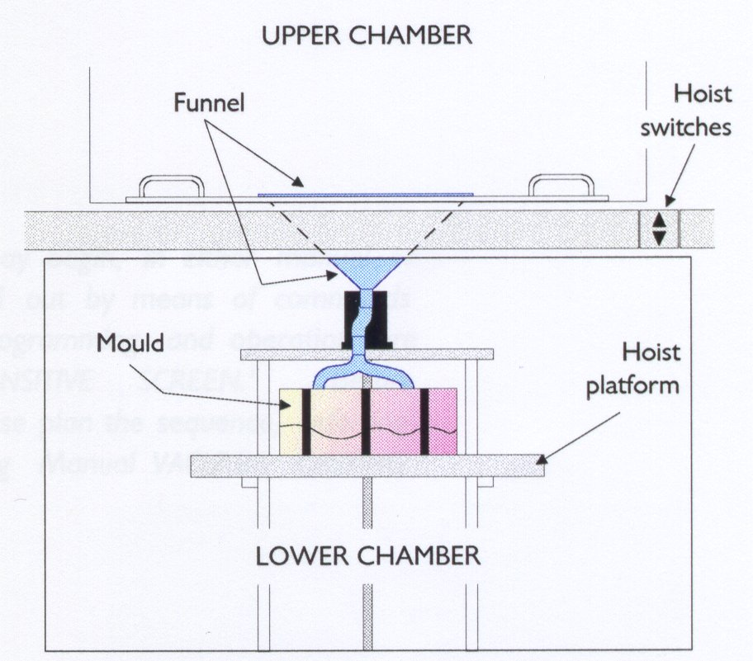

Fig. 7 Arrangement of the mould and accessories

FITTING THE CUPS AND PADDLE

Fit the cups into their cradles, ensuring always that component ‘A’ is in cup ‘A’ (the upper right cup).
- Place cup A in its cradle, engaging the spout with the V-shaped cut-out. Ensure that the lip of the cup (and that of it’s liner, if used) is beneath the lip of the retaining clip.
- Remove the paddle from its clip (above cup B).
- Pull open the retainer assembly (with V-shaped cut-out) for cup B. Slide the cup B into the cradle, ensuring that the lip of the cup (and that of it’s liner, if used) is beneath the lip of the retaining clips at the side and rear of the cradle. Close up the retainer place, keeping the spout of the cup in the V-shaped cut-ut, and lock it by turning anti-clockwise the knob at its left.

Re-fit the paddle by sliding it into its holder, ensuring that it is fully engaged by the spring-loaded ball.

BEFORE BEGINNING A CASTING, ALWAYS HAVE READY THE
APPROPRIATE SOLVENT FOR CLEANING UP RESIDUAL RESIN.

WORKING PROCEDURES

- TO MAKE THE MACHINE READY FOR USE

Switch on the machine at the isolator.
Press the green re-set button (the inside of the chamber is now illuminated).

The machine is now ready for use.

ALWAYS CHECK THAT BOTH RESIN COMPONENTS – AND THE MOULD – ARE IN POSITION BEFORE ATTEMPTING TO MIX AND CAST

- OPERATING MODES

The machine can be operated entirely in manual mode or auto (fig. 16).

KEEP YOUR HANDS OUT OF THE VACUUM CHAMBER WHILE ANY OF THE MECHANISMS ARE OPERATING

- OPERATING IN MANUAL MODE

Select the manual screen.
Press ‘Pump’ to begin chamber evacuation.
Press ‘Speed’ to select the mixing speed.
Press ‘Run’ to start the mixing of part B.
Once the vacuum time has been achieved, stop the mixer.
Press ‘A’ cup down, allowed resin ‘A’ to drain into cup ‘B’
Press ‘A’ cup up.
Re-start the mixer.
When the mixing is complete, stop the mixer and tilt cup ‘B’ by pressing its DOWN button. Allow it to drain before pressing the UP button to return cup ‘B’ to up position.
When the pouring is complete and the resin has settled, press the SLOW LEAK button. The slow leak will start to force the resin further into the mould. This should be continued for up to 30 seconds, after which pressing the FAST LEAK button will release the remaining vacuum fully, forcing the resin completely into the mould.

- USING THE AUTOMATIC OPERATION SEQUENCE

With the mould, accessories and resin components all in place, close the chamber doors.
Select required program
Go to AUTO REPLAY
Start the program.

- STOPPING IN AN EMERGENCY

To deal with unforeseen or unplanned steps in operation (for example, forgetting to load with a resin component, or an apparent malfunction as a result of faulty programming):
Operate the red STOP button (it will lock into place)
The machine is now completely shut down: nothing with operate.

WORKING PROCEDURES continued

- RE-STARTING AFTER EMERGENCY

Rotate and release the red STOP button
Press the green re-set button
Press ‘Esc’ to return to the main screen.

The machine can now be operated again. Gain access to the chamber after first operating the FAST LEAK control to release the vacuum. It will then be possible to correct any fault before continuing.

- SHUTTING DOWN

Complete shut-down: turn off the power supply at the isolator switch.

AFTER CASTING – A REMINDER
Remove the cups and liners, the funnel and the pipes as soon as possible and clean them out with the recommended solvent, ready for re-use.

WORKING PROCEDURES continued

CONTROL PANEL TOUCH SCREEN FUNCTIONS

Title Screen
Fig. 15
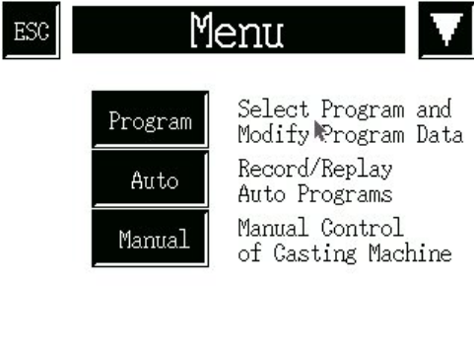The MCP type ‘PLC’ vacuum casting machines are controlled by a touch-sensitive screen, which first appears in the form of fig. 15. Please note that only the lightest of touches is required : do not press the screen unnecessarily hard.
Fig. 16

Touching the screen at any point of this display produces the menu screen of fig. 16.

Menu Screen
Note: the ESC button at the top left corner recalls the display last show, while the ‘down’ arrow at the top right calls up the next screen in a sequence. These buttons have the same functions on whichever screen they appear.

Any of seven function screens – briefly introduced below, and described fully on the pages indicated – can be called up by touching the appropriate button on the Menu screen. The next four are on a separate screen, reached by touching the arrow button.

PROGRAM
Touching the Program button produces the Select program screen (page 17, fig. 19), from which an existing program may be selected. The selected program may then be either operated or modified, as desired.

AUTO
Touching Auto invokes the Auto replay screen (page 20, fig. 33), with its two alternatives. The first monitors a running program, while the second allows a program to be recorded and stored.

MANUAL
The Manual button leads to the Manual control screen, (page 22, fig. 40), from which the operator has step-by-step control.

WORKING PROCEDURES continued

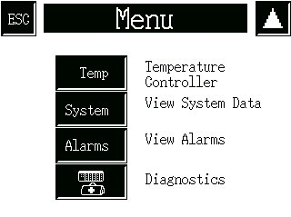
Functions available from Menu screen (continued)
Fig. 17

The second screen, reached by touching the arrow button at the top right corner, is shown in fig. 17

TEMP

Access to the temperature control screen for cup ‘B’ is possible only when the option is actually fitted (see Appendix 1, page 25). If the option is not fitted, the screen in fig. 18 appears when the Temp button is selected.
Fig. 18

SYSTEM
The System data screen (page 23, fig. 41) displays information about running times of the machine and the mixing speeds (which can be altered at the screen) currently programmed.

ALARMS
The Active alarms screen (page 23, fig. 42) shows any current alarm operation. Records of previous alarm operations are also available from the screen.

DIAGNOSTICS
The Diagnostics screen shows the actual PLC input and output states. This is only used to assist with any system fault diagnosis. A battery health lamp warns of the PLC lithium battery condition. If the PLC detects that the internal backup battery has failed the lamp will clear.

WORKING PROCEDURES continued

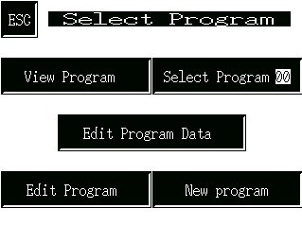
THE PROGRAM SELECTION SCREEN
Fig. 19

Touching Program on the Menu screen invokes the screen shown in fig. 19, from which one of five alternatives may be chosen (apart from Menu, which returns control to the menu screen)

No program can be run from this screen, or any of its subsidiaries : control must first be returned to the Menu Screen.

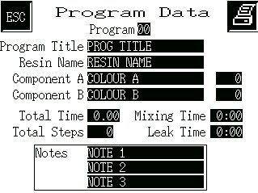
Fig. 20

VIEW PROGRAM
The View program option displays the Program data screen of fig. 20.

This is simply a display of the currently selected program, not modifiable from this screen. The Select program screen can be regained by touching ESC.

Fig. 21

SELECT PROGRAM 00
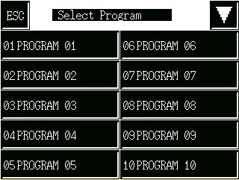
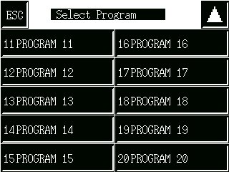
The Select program option (fig. 21) displays the programs that are stored and currently available.
Fig. 3

Touching the arrow button at the top right toggles between similar screens, each with ten stored program options.

Select by touching the appropriate button. After indicating your choice, touch ESC (once or twice, as required) to return to the Select program screen, and again to display the Menu screen.

Fig. 22

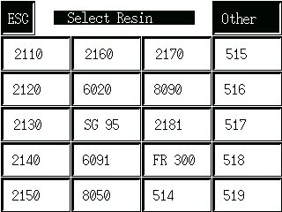
EDIT PROGRAM DATA
The third choice from the Select program screen – available only when a program has already been selected – is Edit program data.

Twenty popular types of resin are shown on the screen (fig. 22), any of which may be selected for substitution in the already-chosen program ; in this case, a series of screens will appear to allow various modifications. When the resin to be used is not shown, the Other button will allow an alternative type to be used in the selected program.

WORKING PROCEDURES continued

EDIT PROGRAM DATA – continued

STANDARD resin type

Selecting a standard resin type first produces the screen of fig. 23, on which the intended weight of the resin casting is entered by means of the and buttons.

The weight may be registered by touching the return button at the bottom right corner, after which the screen of fig. 24 appears.

Each screen that follow in this sequence has an up and a down arrow key to (respectively) return to the previous screen or to proceed to the next.
Fig. 23

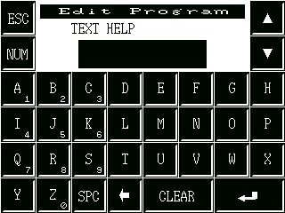
The current title of the program already selected appears (always in capital letters) on the bar above the keys, and it can be edited if necessary.

Touching Clear will remove the existing title, which may then be replaced. Single characters may be removed by the backspace key. The Num key toggles the number pad on and off, highlighting the numbers on a red background when it is operative, allowing numbers to be included at will. SPC gives a space marked by an underline.

The program components are selected by means of the down arrow button, and appear in the following order below the Program bar:
Fig. 24

Colour of component ‘A’
Colour of component ‘B’ (as required)

Notes – 1, 2 and 3 (as required)

and the complete description suite is finally registered by touching the ‘carriage return’ key at the bottom right corner to show the screen of fig. 25. Either choice will return the display to the Select program screen (fig. 21). The entries will appear thereafter on the Program data screen (fig. 20) whenever it is invoked for the particular program.

‘OTHER’ resin type

Fig. 25

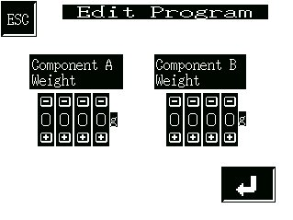
When a resin is to be used that does not appear on the standard list, touching the Other button produces the Edit program data screen of fig. 26. Here, the actual weights to be used of each separate component must be entered (remembering always to identify component ‘B’ with cup ‘B’ in the casting machine).

The carriage return button moves control to the Edit program screen (fig. 24), from where the procedure may be continued. After an initial screen on which the resin name must be entered, procedure is the same as for a standard resin type.

Fig. 26
WORKING PROCEDURES continued

EDIT PROGRAM

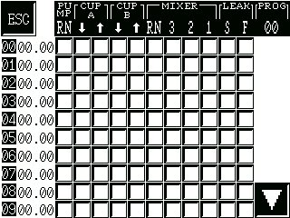
WARNING – the purpose of the Edit program
facility is to display steps in a program already
registered. The displayed program may also
be edited, but such a task should be undertaken only by an experienced operator.
The fourth choice from Select program displays the screen of fig. 27. The left-hand column displays the step numbers of the selected program from 00 to 09 : four further, similar screens display subsequent steps, also in batches of ten, up to no. 49 (the maximum for a program is 50 steps, including 00). The arrow button at the bottom right corner changes to the next display : intermediate screens have two button, for forward and backward movement.
Fig. 27

The buttons in the main body of the display have an on/off toggle action, a green button indicating that a function is active as the step commences. The explanation of the eleven abbreviated column headings is as follows:

PU CUP CUP MIXER LEAK

MP A B

RN ⇓ ⇑ ⇓ ⇑ RN 3 2 1 S F

Pump switch Cup movements Mixer switch: Slow Fast
(up/down) On fast med. Slow leak leak

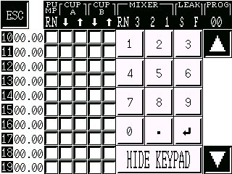

The second column across the screen displays the program time which must elapse before the step occurs. The time may be altered by touching it on the screen, which changes the display to that of fig. 28 (where a number pad has been superimposed by touching the 00.00 adjacent to step 14). The time is accepted by touching the return button, after which further times may be adjusted, or the keypad display hidden. WARNING : subsequent times are not altered automatically and must, when necessary, be changed manually.

Fig. 28

When all entries are completed, the ESC button on the current display shows the screen of fig. 30, where the changes may be confirmed by the Yes button, or rejected by the No button. Either choice returns control to the Select program screen (fig. 21).

Fig.29
WORKING PROCEDURES continued

NEW PROGRAM

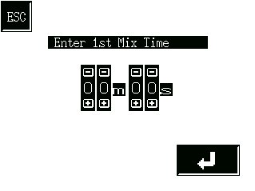
The final choice from the Select program screen is New program, which is used to install functions with a resin already selected and for which the component weights are already specified.

The program name and number should already have been selected. The first display to appear (fig. 30) requires the length of the first period of mixing to be entered (the default is one minute).

Fig. 30

When the time has been correctly entered, it may be registered by means of the carriage return button, which reveals the display of fig. 31, on which the rotation speed of the mixer must be specified. The default speed for the mixer is 1 (low speed).

After selecting the preferred option (the button turning from blue to green), it may be confirmed by means of the carriage return button, which displays a screen similar to that of fig. 30, but requiring the second mixing period to be entered. Again, the default is one minute : if a second period is not needed, the time should be set to zero.

After confirming the second mixing period by touching the carriage return, a fourth display, similar to that of fig. 31, appears for entry to be made of the mixer speed.
Fig. 31

When the second mix speed has been selected, the following screen asks for a Leak Time to be entered.

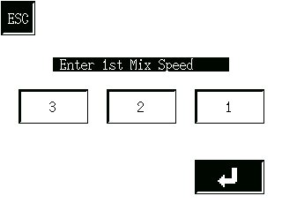
The carriage return on this fifth display brings up the screen of fig. 32, where the changes may be confirmed by the Yes button, or rejected by the No button. Either choice returns control to the Select program screen (fig. 21).

Fig. 32

AUTO RECORD AND REPLAY

On touching the Auto button at the Menu screen, the Auto replay screen (fig. 34) appears, displaying the name of the program already selected.

The program may be run as it stands, or it may be replaced by recording over it. The latter option is not a modification, but requires a complete new sequence to be entered.

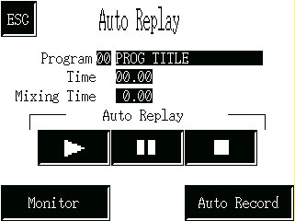
Two buttons – the ‘Play’ and Auto record – flash when the screen is opened.
One of the other of these options must be chosen before continuing.

Fig. 33

WORKING PROCEDURES continued

AUTO REPLAY

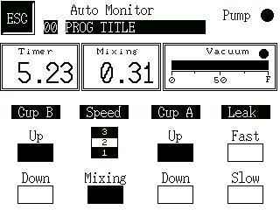
Three buttons control the automatic replaying of a selected program :

 the ‘play’ button begins the program immediately :

 the ‘pause’ button stops the program temporarily :

 the ‘stop’ button returns the program to the beginning.

Touching the Monitor button (fig. 33, page 20) enables progress of the program to be followed.
Fig. 34
The full bar beneath Pump indicates progress during initial evacuation of the chamber, completion being shown by the OK button.

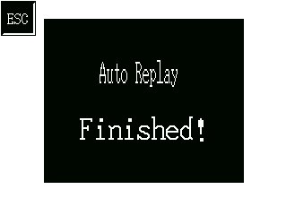
A lamp indicates an operation in progress. In the example shown, the pump is running, while the program time yet to elapse is 5 min. 23 sec. And the mixer has been running at medium speed for 31 sec. Note : the counter runs forward during recording, but backward during replay.

The end of the sequence (normally, when the vacuum has been completely released), is indicated by the appearance of the Auto replay display of fig. 33 (page 20). The ESC button on this screen also returns control to the display of fig. 33.
Fig. 35

AUTO RECORD

Selecting Auto record from the Auto replay screen brings the display of fig. 36, where :

the ‘stop’ button ends and deletes the recording ;

the ‘auto record’ button starts program records ;

the ‘pause’ button temporarily halts recording.
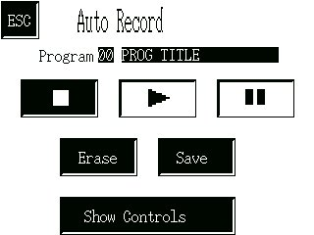

Fig. 36


The program already selected will usually need to be eliminated by touching the Erase button, which produces the confirmatory display of fig. 34.

The No, like the ESC button, returns control to the previous screen (fig. 33, page 20).

The Yes button also returns to the previous display, but the ‘auto record’ button now flashes green, prompting the operator to initiate a recording sequence.

Fig. 37

WORKING PROCEDURES continued

AUTO RECORD (continued)

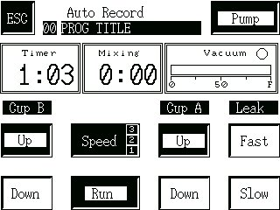
After confirming the start of recording by touching the flashing button, Show controls (flashing) displays the Auto recording screen (fig. 38). From this screen it is possible to record From this screen it is possible to record the new sequence of actions, but not to change the data on the resin*.

Any button showing on this screen may be used, changing to black when active (the Up button for each cup opens in black, indicating the starting position). In the example of fig. 38, the pump has been running for 1 min. 3 sec., not yet sufficient for evacuation (shown by the bar beneath Vacuum) to be complete.
Fig. 38

To record the program it is necessary only to operate the various controls at the appropriate moments. The actions taken are indicated by changes in the button colours, while times elapsed are all indicated automatically. The
program steps have a resolution of one second : in other words, a one-second
increase in program time must elapse before the next step begins (for example,
a one-second delay must occur between changes of mixer speed).


A maximum of fifty program steps (00 to 49) is possible. At the last of these steps, the Memory Full warning display appears (fig. 39). It is extremely unlikely that this condition will occur in normal practice.

The final steps of a sequence will be :
- switch off the pump ;
- slow leak on ;
- fast leak on ;
- slow leak off ;
- fast leak off.

Fig. 39

After the last step has been entered, the ESC button is pressed to return control to the Auto record screen, on which the ‘stop’ button, seen to be flashing, must be touched to terminate the sequence. The program may now be deleted (e.g. if a mistake is believed to have been made) by touching Erase, when a new recording attempt may be carried out : or it may be accepted by selecting Save.

The ESC button now returns control to the Auto replay screen, from which the program may be replayed. Alternatively, the Menu screen may be selected where, if necessary, the resin data may now be changed*.

MANUAL CONTROL OF MACHINE
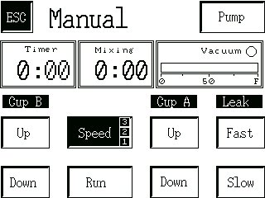
On touching the Manual button at the Menu screen, the Manual control display of fig. 40 appears.

With the mould mounted and the resin components already weighed out into the cups, a sequence may be run under complete manual control from this screen. The resin type and weight do not need to be entered before beginning.

The operations are exactly as already described for Auto record, and must include the same final steps of the sequence.

When casting is complete, ESC returns control to the Menu screen.
Fig. 40

*see EDIT PROGRAM DATA (page 17)

WORKING PROCEDURES continued

SYSTEM DATA

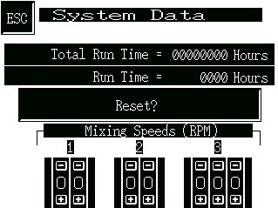
Selecting the System data display from the Menu screen reveals data relevant to maintaining the machine.

The Run time shown is re-settable. It should be set to zero when the pump oil is changed, and is then useful in determining the proper time for the next change. If the Reset button is selected, the Are you sure? screen (fig. 37) appears.

The total operating time of the machine is approximated by the Total Run Time, which is in fact the length of time for which the vacuum pump has been operated. Since the machine will seldom be operated to any significant extend unless the chamber is under vacuum, this provides a reasonably good estimate.
Fig. 41

MIXER SPEEDS

The maximal values for the mixer speeds are the settings in place when the machine is delivered:

1 2 3
49 99 160 (r.p.m.)

The settings may be adjusted in the usual way to values appropriate to the task in hand, and when the Menu button is invoked the new current values will be recorded.

ALARMS

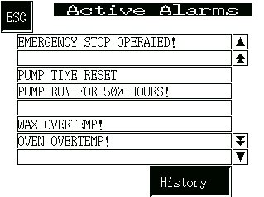
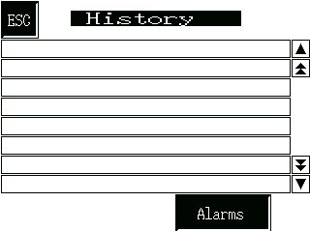
Malfunctions and program faults cause an alarm condition, which can be investigated by examining the Active alarms display (fig. 42). Note that, in certain conditions, this display may appear at start-up*.

FAULT CONDITIONS
In the example shown, use of the emergency button has been automatically recorded. Other fault conditions, which may have occurred, are similarly recorded.

VACUUM PUMP
Fig. 42
It is recommended that the oil in the vacuum pump should be changed every 500 hours and among the fault conditions is a warning that the time limit has expired. When the limit has been exceeded, an attempt to operate the machine will cause the Active alarms display to appear with the message ‘Pump run 500 hours’. This does not prevent further use of the machine, but is a regular warning that the pump oil should now be changed which will recur until the Run Time has been re-set at the System data display.

HISTORY OF FAULTS
Touching the History button produces the display of fig. 43, which lists the alarm conditions that have occurred, with the time and date (without the year) also indicated.

Fig. 43

*see also page 12, no.1
ROUTINE MAINTENANCE PROCEDURES

Apart from keeping the unit in a generally clean condition, routine maintenance of the Vacuum Casting Machine is concerned with the vacuum pump and its associated filters. Users are referred to the Service Manual for other repair or replacement procedures.

* Before carrying out any operation on the vacuum pump or its filters, allow the equipment to stand idle for at least one hour.

* Never use any oil but the correct grade as recommended.

* Check the oil level regularly. The optimal frequency depends greatly on usage and should be set after observation at short intervals (e.g. daily or weekly) during the first periods of use.

OIL CHANGES

The first oil change for a new pump should be made after 150 hours of operation.

The period between subsequent changes may be varied to match actual usage. Assuming a full working week of forty hours, MCP Equipment suggest that the oil be changed at intervals of three months, corresponding to 520 hours (refer to the maintenance schedule in the pump manufacturer’s manual in case of any doubt). Longer periods allow the build-up of sludge and other deleterious matter, which may shorten the life of the pump by causing excessive wear.

A copy of the pump manufacturer’s manual is supplied with the casting machine. For the user’s convenience, the following instructions summarise the procedure for maintenance of the pump, but the manual itself should be consulted for explicit instructions for changes of oil and/or filter as well as other cleaning operations.

- Remove the oil filler cap from the top of the pump

- Open the drain tap at the bottom left of the pump and allow it to drain (through a hose) into a suitable receptacle.

- When the oil-flow appears to have ceased, operate the pump for no more than thirty seconds with the vacuum chamber doors open.

- Close the drain tap and put in one litre of fresh, clean vacuum pump oil. Replace the filler plug.

- Close the vacuum chamber doors and operate the pump for three or four minutes, to flush out residual deposits.

- Repeat operations 1, 2 and 3.

- Close the drain tap and refill the pump with fresh, clean oil to the gauge on the sight window. Replace the oil filler cap.

Operating the machine in very humid conditions can cause moisture to be drawn into the vacuum pump, where it will form a layer of water at the bottom of the sump and cause the level to rise about the gauge line. If you notice this effect (which is most easily discernible after a period of non-use, such as over a night), drain off the layer through the drain tape to bring the oil down to its correct level.

DECLARATION OF CONFORMITY

Manufacturer’s name and address: MCP EQUIPMENT
(A DIVISION OF MINING & CHEMICAL PRODUCTS LTD.)
UNIT 8, WHITEBRIDGE INDUSTRIAL ESTATE,
STONE
STAFFORDSHIRE ST15 8LQ

Equipment type and designation: Vacuum Casting Machine
Type 001PLC and variants

Serial Number: …………………………………………………

Directives/Regulations to which
the equipment conforms: 1. Council Directive 89/392/EEC and its amending directives, leading in the United Kingdom to The Supply of Machinery (Safety) Regulations (SI 1992 No. 3073) (as they apply to equipment with a moving part and intended for treating or moving material.

2.Council Directive 89/336/EEC and its amending directives, leading in the United Kingdom to The Electromagnetic Compatibility Regulations (SI 1992 No. 2372).

3. Council Directive 72/23/EEC and its amending directives, leading in the United Kingdom to The Low Voltage Electrical Equipment (Safety) Regulations (SI 1989 No. 728).

Safety standard to which the
equipment uses: BS 2771 : Part 1, as applicable to the electrical and electronic equipment of machines not portable by hand when working, used in industrial production and operated from a supply up to 1000 V a.c. (equivalent to European standard EN 60 204).

Person responsible for
Technical File: Simon Scott,
Manager for Technical Data – MCP Equipment Division

